+ Generations Together

Grateful

Here is a cross-generational session for all members of the congregation exploring the value of gratitude and its importance in for our preparation to celebrate Thanksgiving. This session is designed to be conducted in about 90 minutes, and can be adapted for a shorter or longer timeframe.

Introduction
This session works well just prior to Thanksgiving. It will allow participants to explore stories and events of their lives for which they are grateful, and in the spirit of the holiday, they will bring some good to others who are less fortunate.

I. Gather
[use the following adaptation of the activity Serious or Not—Thanks)

Prepare in Advance
Ask each person coming to session to bring one item that is a symbol or reminder of a blessing for which he or she is thankful. Offer the following categories to prompt their creativity:
- Person: Photo or object that is a reminder of a person who has been a blessing.
- Place: Photo or memento of a vacation spot or a beloved corner of the home or yard.
- Thing: Some device or object that has made life easier.
- Event: Photo or memento of an event that brought joy this year.
- Talent: Something that symbolizes a talent that has been enjoyed.
- Mistake or misfortune: Something that symbolizes a mistake or misfortune that turned out to be a blessing.
- If you choose to do the variation in Step 5 below, ask each person to also bring a usable item of clothing (or new toy or nonperishable food) to give away.

Activity Plan
- Gather all participants together and conduct a brief ice-breaker activity that helps people learn the names of at least some of the others gathered.

- Offer the following prayer to begin the session:

Generous God, source of all life, we give thanks today for all the people, places, and things that have enriched our lives this past year. We are grateful for the happy times and the times we’ve cried out of loss or pain, for both bond us to one another. We are thankful for successes and failures, for even the failures testify to our humanity. We are grateful for things that make our lives easier and lighten our heart. For all things, serious or not, we give thanks.

- Ask participants to take the object that they have brought with them and form mixed groups of no more than 4 – 5 persons. Mixed groups means that family members should not remain together for this part of the session (however, small children may want to remain with a parent, and that is okay.

- In the mixed groups each person should, in turn, to show the object representing his or her thanks, and explain what it means. Invite each person to conclude by saying: I thank God and my family and friends, and perhaps some of you for being in my life this past year.

- After each person has offered his or her item and thanks, ask participants to bring forward the usable items of clothing (or toys or nonperishable food) so that they may be given to a serving organization in your community.

- Bless the items that have been donated and conclude by saying:

For all these things and more, we give you thanks, O God. Amen.

II. Grow
During this part of the session families with young children will engage in an adaptation of the activity called Thankful Tree], and families with teenagers or households with adults will engage in an adaptation of the activity call Thanksgiving Stories.

Invite all participants to form family groups or small groups of 3-5 persons. Take the groups with young children to another room and conduct the following activity.

Activity Plan for Families with Young Children

Needed
Thanksgiving Scriptures worksheet (see pg. 9), plain paper, large piece of newsprint for each group, brown construction paper or brown paper grocery bag, scissors, tape, pencils, washable markers – enough of all these items for multiple groups to engage in the activity simultaneously.

Prepare in Advance
Make a copy of the Thanksgiving Scriptures worksheet for each family member.

Activity Steps
- Ask each person to use a pencil to trace his or her hands on plain paper. Have each person cut out his or her paper hands. Help younger children if they have difficulty handling scissors.

- On one paper hand, have each person write his or her name in the palm of the hand and write one thing she or she is thankful for on each finger and thumb. Help younger children by printing words lightly in pencil for them to trace. On the other paper hand, use markers to draw some things for which you give thanks.

- Work together to cut a tree trunk from brown construction paper or a paper grocery bag. Tape the trunk to your piece of newsprint.

- Have each person tape his or her paper hands to the brown paper trunk, arranging them as if they were leaves. Ask each person to tell about one thing for which he or she is thankful and why.

- Give each person a copy of the Thanksgiving Scriptures worksheet. Have each family member choose a scripture to read aloud choose one or two verses to read in unison.

- End by giving God a cheer of thanks and a round of applause. Take your Thankful Tree home and display it in a prominent place at least until Thanksgiving Day.

Activity Plan for Families with Teens and for Small Groups of Adults

Needed
Deuteronomy 6:4-5 worksheet), scissors, tape or glue stick, small spiral notebook or plain paper folded in half and stapled together to form a booklet, pen – enough of these materials so that each family/small group gets a worksheet and a booklet.

Prepare in Advance
- Make a copy of the Deuteronomy 6:4-5 worksheet and cut out the verse box.
- Glue or tape the verse box to the cover or first page of each spiral notebook or folded paper booklet.

Activity Steps
- Give the notebook or booklet to each family/group and read the verse aloud. Explain that the notebook will be passed among yourselves, and each person is encouraged to think of one family story that is an example of God’s love at work in your family and to write it in the booklet.

- As time allows, read aloud just one or two of the stories.

- Instruct families to take the booklet home and to read aloud all the stories at various times on Thanksgiving Day.

- Conclude this session by asking family groups to talk about ways they can share the stories with any family members who could not join them for Thanksgiving. For example:
- Photocopy the booklet for each family member.
- Scan the booklet and post it on a private family blog.
- Scan the booklet and send it as an email attachment to family members.
- Make a recording of a family member reading the stories and send copies of the recording to family members.

III. Go Forth
To conclude the session ask participants to re-form the same mixed groups that they started with.

Activity Plan

- In mixed groups invite participants to share their responses to the following questions:

- What do you appreciate most about your family?

- The whole world would be better off if we all showed more gratitude for _____________________.

Invite some participants to share their responses with the whole group.

- Handout of the activity called Gratitude Box – one copy for each household. Tell them that this activity is their “homework” to be completed before Thanksgiving Day.

- Conclude the session with the following prayer:

God, we know the power of a story. In Scripture we read the stories of your faithfulness, grace, and love. Today, as we gather as a family, we give thanks for being a part of your story as we live our lives for you. Be with us as we celebrate the stories we share as a family and helps us to recognize these stories as signs of your blessings in our lives. Amen.

Set up a nativity set on center table for all to see. Invite young people to share what they know about the different characters and figures in the set. If this particular nativity set has a special history to the family, this is a good time for someone to share that story.

- Work as a group to name other characters or creatures in the story of Jesus’ birth that are not featured in the nativity set (many sets do not have shepherds or even Joseph). Have someone make a place-holder for each character or creature you have listed. Do this by drawing them or making them out of play-dough. Enjoy the creative process and have some fun working together, even if the creations don’t look as professional as your nativity set.

- Once you have set the extra pieces in your nativity set, form family or small groups, get your Bible read the following Scriptures passages to those in your group. Work together to make a list of all the characters and creatures listed in the story.
- The Birth of Jesus, Luke 2:1-40
- The Birth of Jesus, Matthew 1:18 – 2:23

- Compare your new list of characters and creatures to the original nativity and your added pieces. Use the following questions to guide your conversation. If needed, go back and look at the Scripture passages again.
- How did Mary and Joseph get to Bethlehem from Nazareth?
- What characters or creatures shared their sleeping quarters?
- Who came to greet the newborn baby on the first night?
- Where did the Magi (or kings) greet the baby and who else did they see?
- I wonder if the Magi saw the baby before his presentation in the Temple. What do you think?
- I wonder how Magi from different countries and cultures knew about Jesus. What do you think?
- Who do you think was the most uncomfortable on the first Christmas?
- I wonder what other teenagers said about Mary back home.
- Which character do you most identify with and why?
- What most surprised you in this reflection on the Christmas story?

- Remind participants to take home their Advent Chains. Then close the session with this prayer.

God, as we look back and remember the story of the first Christmas, help us to remember that countless unnamed characters probably played a role. Help us to be characters in the Christmas story this year, even if our story isn’t told. Help us to share Christ’s light, even if we don’t’ get our name in a book. May this nativity remind us of the Christmas story, of this time together as a Christian family, and may it help us live out the story in each of our lives. Amen.

Serious or Not—Thanks
By Susan Vogt
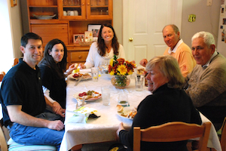
creativecommons.org/licenses/by/2.0/
Thanksgiving dinners are traditional, and so is saying grace before the meal. Liven up your table prayer at Thanksgiving with some forethought and these ideas for a more creative expression of thanks.

For
Adult, Couple

Season
Fall

Needed
Thanksgiving dinner, large basket

Prepare in Advance
Ask each person coming to Thanksgiving dinner to bring one item that is a symbol or reminder of a blessing for which he or she is thankful. Offer the following categories to prompt your guests’ creativity:
- Person: Photo or object that is a reminder of a person who has been a blessing.
- Place: Photo or memento of a vacation spot or a beloved corner of the home or yard.
- Thing: Some device or object that has made life easier.
- Event: Photo or memento of an event that brought joy this year.
- Talent: Something that symbolizes a talent that has been enjoyed.
- Mistake or misfortune: Something that symbolizes a mistake or misfortune that turned out to be a blessing.

If you choose to do the variation in Step 4 below, ask each guest to also bring a usable item of clothing (or new toy or nonperishable food) to give away.

Activity Plan
- Before the meal is served, gather at the dining table and place the basket in the middle. The person serving as the prayer leader opens with the prayer below:

Generous God, source of all life, we give thanks today for all the people, places, and things that have enriched our lives this past year. We are grateful for the happy times and the times we’ve cried out of loss or pain, for both bond us to one another. We are thankful for successes and failures, for even the failures testify to our humanity. We are grateful for things that make our lives easier and lighten our heart. For all things, serious or not, we give thanks.

- The prayer leader then invites each person, in turn, to show the object representing his or her thanks, explain what it means, and place it in the basket. Invite each guest to conclude by saying: I thank God and all of you for being in my life this past year.

- After each person has offered his or her item and thanks, the prayer leader concludes by saying:

For all these things and more, we give you thanks, O God. Amen.

- Variation: In the spirit of Thanksgiving, gather usable items of clothing (or toys or nonperishable food) to give to a serving organization in your community.
Thankful Tree
By Jolene Roehlkepartain

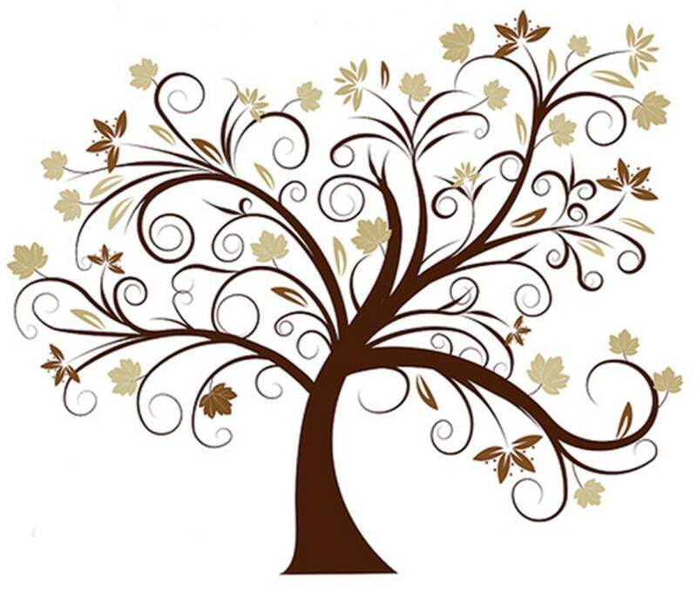
creativecommons.org/licenses/by/2.0/ 1

Name what you’re most thankful for as you create a seasonal decoration for your home.

For
Young Family

Season
Fall

Needed
Thanksgiving Scriptures worksheet (see next page), plain paper, brown construction paper or brown paper grocery bag, scissors, tape, pencils, washable markers

Prepare in Advance
Make a copy of the Thanksgiving Scriptures worksheet for each family member.

Activity Plan
- Say this prayer aloud to begin:

God, thank you for giving us so much—food, clothing, home, friends, family, schools, jobs. Amen.

- Ask each person to use a pencil to trace his or her hands on plain paper. Have each person cut out his or her paper hands. Help younger children if they have difficulty handling scissors.

- On one paper hand, have each person write his or her name in the palm of the hand and write one thing she or she is thankful for on each finger and thumb. Help younger children by printing words lightly in pencil for them to trace. On the other paper hand, use markers to draw some things for which you give thanks.

- Work together to cut a tree trunk from brown construction paper or a paper grocery bag. Tape the trunk to your refrigerator or another prominent place in your home.

- Have each person tape his or her paper hands to the brown paper trunk, arranging them as if they were leaves. Ask each person to tell about one thing for which he or she is thankful and why.

- Give each person a copy of the Thanksgiving Scriptures worksheet. Have each family member choose a scripture to read aloud choose one or two verses to read in unison.

- End by giving God a cheer of thanks and a round of applause.
Thanksgiving Scriptures

Psalm 118:24
This is the day that the Lord has made;
let us rejoice and be glad in it.

Ephesians 5:20
Give thanks always and for everything to God the Father in the name of our Lord Jesus Christ.

Psalm 136:1
Give thanks to the Lord, for he is good,
for his steadfast love endures forever.

Colossians 3:17
And whatever you do, in word or deed, do everything in the name of the Lord Jesus, giving thanks to God the Father through him.

Ephesians 1:16
I do not cease to give thanks for you, remembering you in my prayers.

1 Thessalonians 5:18
Give thanks in all circumstances; for this is the will of God in Christ Jesus for you.

Psalm 100:1-5
Make a joyful noise to the Lord, all the earth!
Serve the Lord with gladness!
Come into his presence with singing!
Know that the Lord, he is God!
It is he who made us, and we are his;
we are his people, and the sheep of his pasture.
Enter his gates with thanksgiving,
and his courts with praise!
Give thanks to him; bless his name!
For the Lord is good;
his steadfast love endures forever,
and his faithfulness to all generations.

Colossians 3:15
And let the peace of Christ rule in your hearts, to which indeed you were called in one body. And be thankful.

Thanksgiving Stories
By Audrey Cox
creativecommons.org/licenses/by/2.0/

When families gather for holiday celebrations, treasured family stories are often told. This activity highlights the ritual and tradition of family storytelling and captures it for generations to come.

For
Teen Family

Season
Fall

Needed
Deuteronomy 6:4-5 worksheet (see next page), scissors, tape or glue stick, small spiral notebook or plain paper folded in half and stapled together to form a booklet, pen

Prepare in Advance
Make a copy of the Deuteronomy 6:4-5 worksheet and cut out the verse box.
Glue or tape the verse box to the cover or first page of the spiral notebook or folded paper booklet.

Activity Plan
- As your family gathers for Thanksgiving, pray this prayer aloud:

God, we know the power of a story. In Scripture we read the stories of your faithfulness, grace, and love. Today, as we gather as a family, we give thanks for being a part of your story as we live our lives for you. Be with us as we celebrate the stories we share as a family and helps us to recognize these stories as signs of your blessings in our lives. Amen.

- Show the notebook or booklet you’ve prepared and read the verse aloud. Explain that you will pass it around among yourselves for the rest of the day. Encourage everyone to think of one family story that is an example of God’s love at work in your family and to write it in the booklet when it is passed to them. Explain you will gather later in the day to read the stories.

- Take some time at the end of Thanksgiving Day to read the stories written in the booklet. Talk about ways to share them among yourselves and with any family members who could not join you for Thanksgiving. For example:
- Photocopy the booklet for each family member.
- Scan the booklet and post it on a private family blog.
- Scan the booklet and send it as an email attachment to family members.
- Make a recording of a family member reading the stories and send copies of the recording to family members.
Deuteronomy 6:4-5

Glue or tape this verse to the cover or first page of your spiral notebook or folded paper booklet:

The Lord our God, the Lord is one. You shall love the Lord your God with all your heart and with all your soul and with all you might.
Deuteronomy 6:4-5

