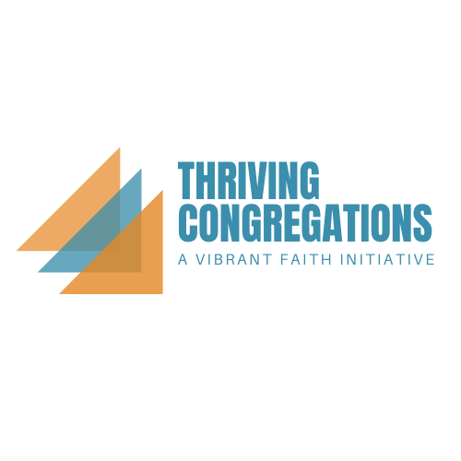
Relational Module Tool

Thriving is the increased capacity to be present to God; the increased capacity to be present to one another; the increased capacity to be present with one another to the world.

The characteristics of a thriving church in the book of Acts:
Deeply connected to Jesus; Focused on Relationships

Outcomes of the Relational Module:
- TC churches will reclaim the impact of a lack of relationship on the formation of faith.
- TC churches will reclaim the power of relationships for thriving as a church.
- TC churches will look at the depth and transforming nature of their church’s relational networks.

- What insights from the Relational Learning module are important for your church?
- In what ways does your church practice the presence of God?
What specific ways do you see people being “grafted” into the Vine?
What is one practice that you’d like to do more of to help your church be more present to God? Where will you start? With what groups of people?
- What are the sources of deep, ongoing, transformational relationships at your church?
Who are some people at your church who could benefit from a more direct focus on relationships?
What is one practice that you’d like to do more of to help your church to be more present to one another? Where will you start? With what groups of people?

